**How to turn on a domain that is off in iReady**

If a student fails a certain amount of lessons the domain will turn off. If all of the domains are turned off the student will not have access to any iReady lessons.

1. Once you are logged in to your iReady account click on monitor personalized instruction.

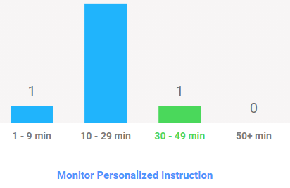

1. When viewing the report you will see an alerts column. If the child has a red alert that means the domain was shut off, if the child has a yellow alert that means the child may be struggling and the domain could be turned off soon.
2. Click on the student’s name to access an individual report.

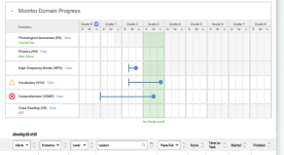

1. To turn the domain back on click on view next to the domain with the red alert.
2. 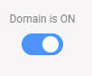It will say the domain is turned off and you can switch it to turn it back on.



1. Then press the green arrow on the bottom.
2. Repeat as necessary depending on the child.
3. Refresh the page. When the child logs back in to iReady they will have access to lessons in the domains that were turned back on.